S-WEB 6 VC. Voice Command — Website and App Maker
20.09g) S-WEB 6 VC. Voice Command — Website and App Maker 💥 (28 Oct 2023)

By Nick Ray Ball

Friday – Oct 27, 2023

Hi Blaze,
Here is the work I did yesterday, which is going to go on the home page of S-World.org and is simple enough to become Cape Villas Ltd.’s first presentation for Innovate UK.
The AI company I spoke with, wanted to have the concepts on the website of it generalised, and here it is. But done in a way that can use either Open AI, Meta or Google’s LLM.
Please have a read-through and tell me what you think.
I have to do a little bit of work on the pictures, I've only just thrown them in quickly. But I'm pretty happy with this now I need to make the video of me making a new template, during which process I will be able to test all of the widgets to make sure they're still functioning.

S-Web 6 VC.

Voice Command — Website and App Maker 💥

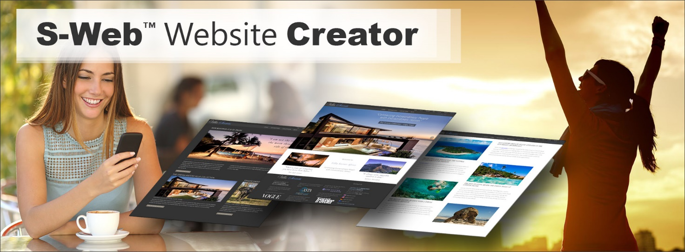
973 Words: (Now 1013)
Above, we see a lady in the sun enjoying coffee, using the S Web 6-VC Voice Commands App to make a website app, that will be better than her boss’s company website, and at the same time make you money, if you have one product or service that you could sell.

A website that if you wanted to take full advantage of affiliate (money for nothing) opportunities would take a WordPress designer their entire life to build.
S-Web 6 VC = Voice Controlled will be powered by one, some or all four 4 LLMs
We've been giving our banks verbal instructions by the phone for decades, what is new is the ability to have those verbal instructions fed into an LLM (large language model AI) such as GPT 4, LLaMa 2 or Bard AI and have them easily translated into perfectly executed instructions. In this video I'm demonstrating exactly how those instructions would work, to create an S Web 6 website and its home page.

This video is being made for 5 different audiences, Innovate UK, web development subcontractors, AI subcontractors, clients such as Sotheby's International Realty and Airbnb, and investor partners from the Gates Foundation, Archewell and Virgin Unite, and from Silicon Valley Peter Theil and John Doerr from whom we need 30% of project funding of £4,000,000.

Video steps 1 & 2. Choose a Theme and a Template

Choose a theme - Villa Secrets Luxury Theme
The theme is the overall look of the website or app
Currently, we only have one theme attached to S-Web 5.
For S-Web 6 we will create many different themes and designers will be encouraged to create for the platform by the T2. Quanta Analytica.

For now, we're choosing the Villa Secrets Luxury Theme.
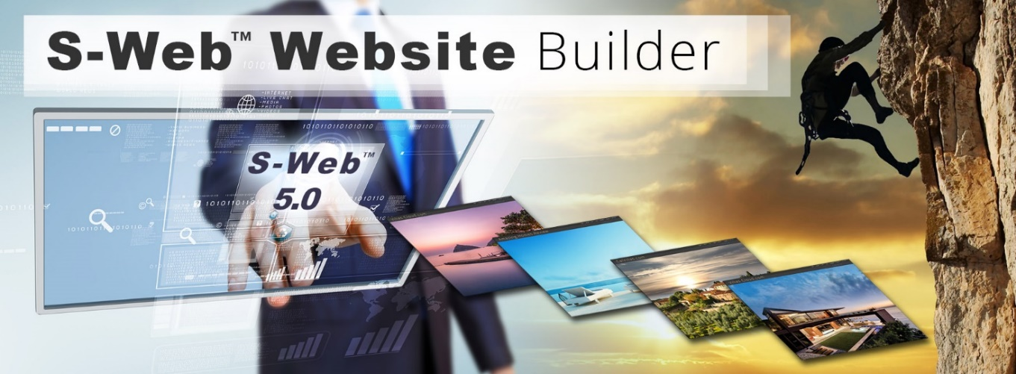

Show four different template examples.
  - Cape Villas.com Default
  - Experience Africa.com No Slider
  - Lux Guides.com Lightweight
  - Luxury Villas Africa Created in this Example.
  - If the user is not happy with these four, they ask the LLM to show the next selection, there are currently 20 sites available and about 60 different homepage variations.
[At this point I asked GPT to lend a hand]
https://chat.openai.com/share/79900ca4-1111-4b82-89eb-743b7a0da7d3

Duplicate Template:
http://www.villasecrets.com/cms/NewSearchHomes.php?tab=Make-Template
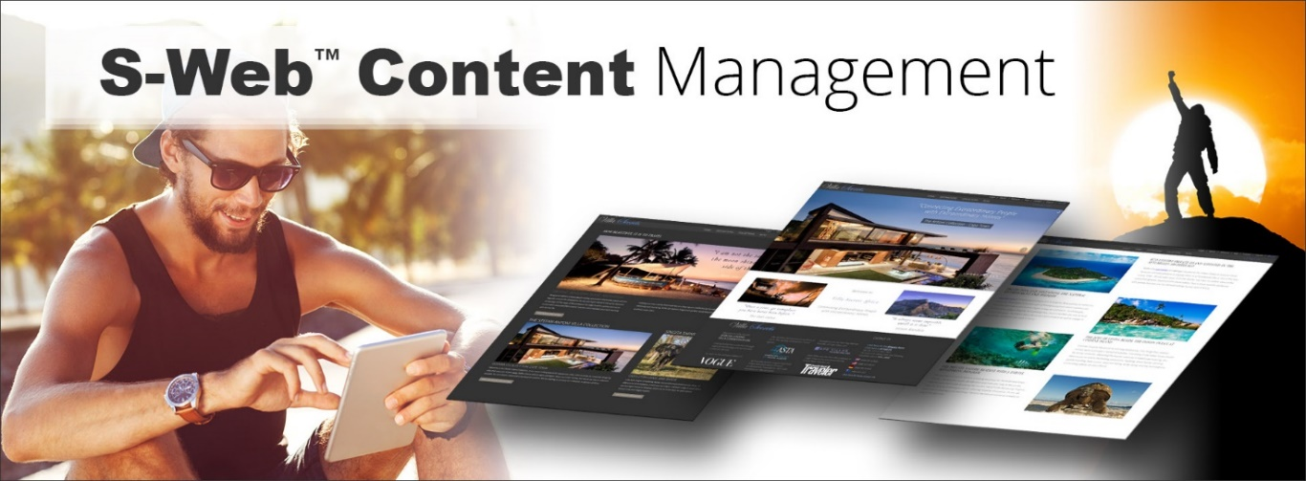
Creating a Site for a California-Based Travel Company called www.LuxuryVillasAfrica.com
  - In this example we're creating a site for high-end African travel experiences, focusing on safaris, villas, and private islands.
    - Current speed issues for California users will be fixed once CDN and optimization are in place.
  - This is my maiden attempt at designing a mobile-specific template!
    - We halted CMS development on the Villa Secrets theme before finalizing the mobile homepage.
Even so, the current design is visually appealing on mobile.
    - All elements display on both mobile and desktop, excluding the big top slider on desktop and the slider at the bottom of the homepage on mobile.
  - 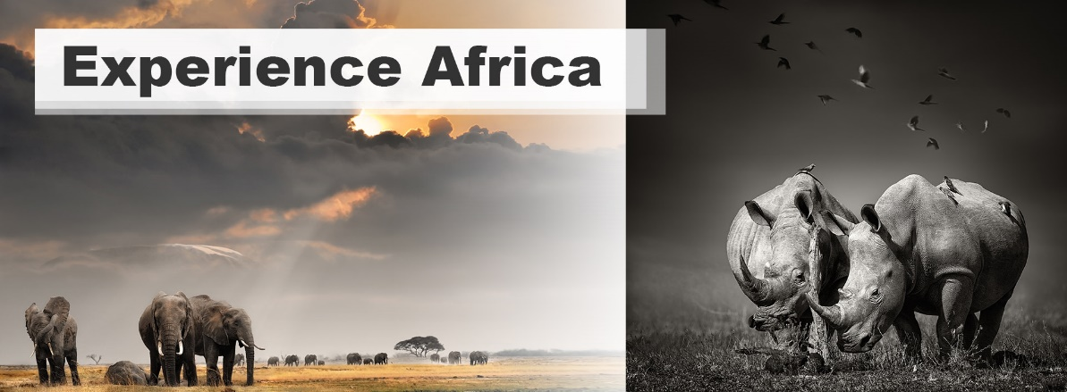
The Experience Africa template seems the best fit for this project.
    - I'll replicate the Experience Africa template, updating the title to "Luxury Villas Africa".
  - Additional adjustments include adding a caption and altering the first six displayed villas.
  - On mobile, showcasing these villas is pivotal as they form users' initial impressions.
    - My design philosophy emphasizes product presentation. Still, templates can be tweaked as per user preferences.
    - Users can choose to highlight website or search term names, as seen on experienceafrica.com. Both strategies have their merits.
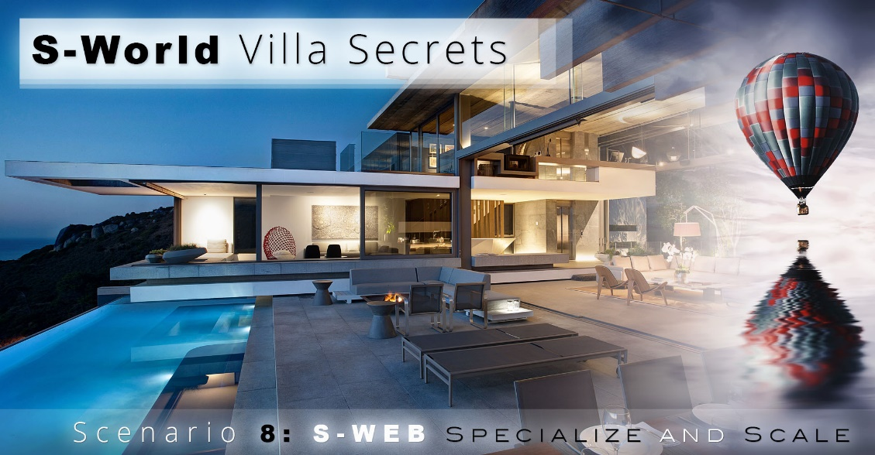

Exploring the S-Web 5.1 CMS Widget Designs:
  - The primary aim is to showcase the straightforwardness of the row-based widget system.
    - Achieving a harmonious design execution across both mobile and desktop is challenging, but essential.
  - It's vital to remember the growing dominance of mobile usage.
    - While mobile is prevalent, many users still rely on desktops or tablets for detailed analysis, especially for high-value transactions like $100,000 bookings. Both platforms must offer impeccable user experience.

Looking ahead: S-Web 6's development:
  - It will likely be written in PHP, aligning with the predominant language of travel GDSs and PMSs.
  - Hybrid app design is on the horizon, integrating existing PHP and Python elements. This melds with specific programming languages: Swift for iOS and Java for Android.
  - A versatile API will be a cornerstone of S-world and S-web. This API will:
    - - Interface with PHP platforms, facilitating seamless interaction with other PHP-based systems.
    - - Connect with Python, enabling robust AI interactions, especially with LLMs for voice-to-action commands.
    - - Support app development by translating data for iOS and Android environments.
    - - Potentially communicate with Microsoft-based applications, though this is a lesser priority.

The Game-Changer - The SWF (Swapping Menus Function) 💥

"Whether you're an innovator seeking groundbreaking solutions, a developer with an ear to the ground, or a business with aspirations for global reach – imagine the boundless possibilities with S-Web 6.

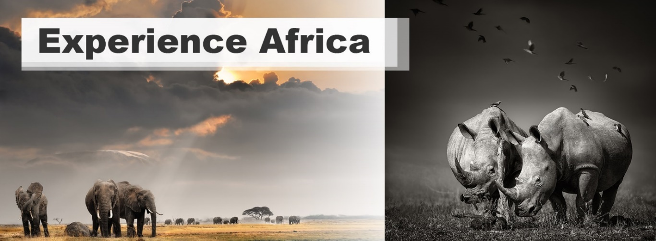

For governmental programs like Innovate UK and Bridge AI – envision a system that boosts the UK's technological frontiers while optimizing expenditure. Think of the potential ROI when a system can turn a simple $2,000 villa booking into a whopping $10,000 commission, just like Cape Villas did, thanks to the seamless integration of Experience Africa's offerings right on their site!
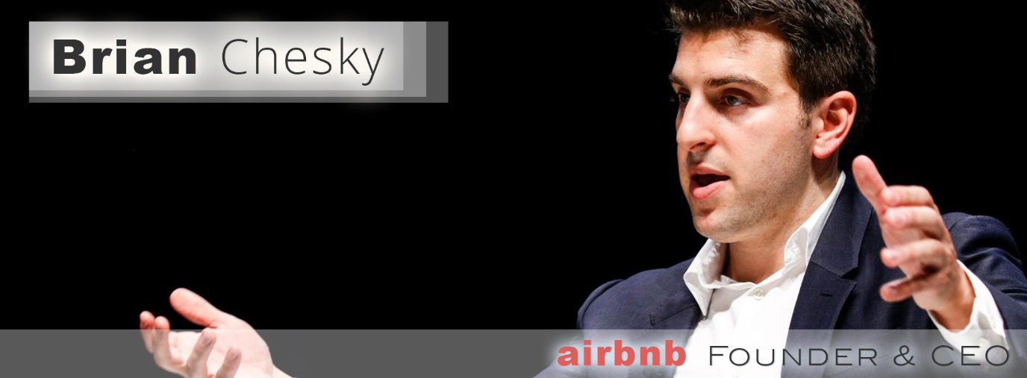
To our invaluable AI subcontractors, picture creating transformative integrations where anyone, even over a casual cup of coffee, can build an entire website verbally from an unassuming cell phone. To the web development community, collaborating with Nick Ray Ball DevOps, let's pioneer a CMS that intuitively responds to verbal commands, right from its inception.
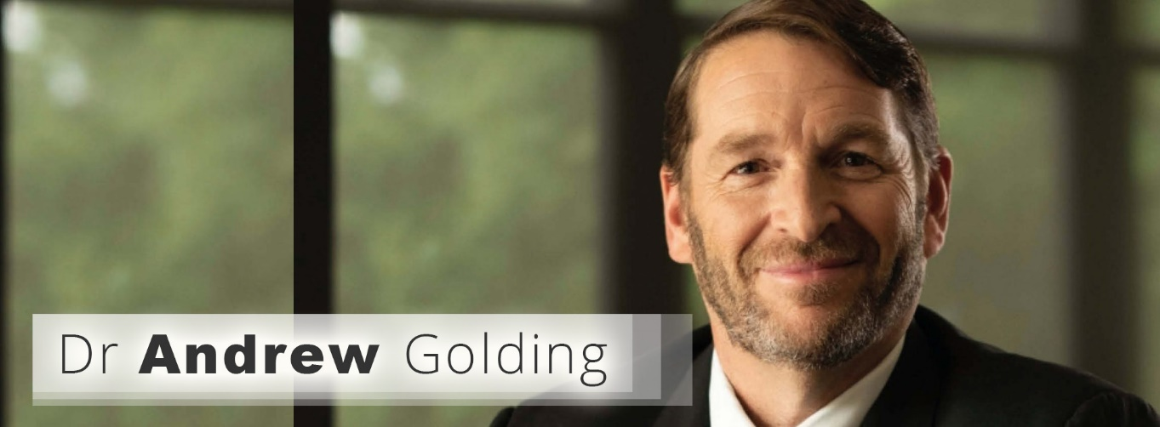

Potential users, from dynamic SMEs to powerhouses like Sotheby's International Realty: unlock a world where your online presence isn't just about showcasing, but cross-selling and amplifying profits. Remember S-Web's genesis in 2009? This is the next big leap.
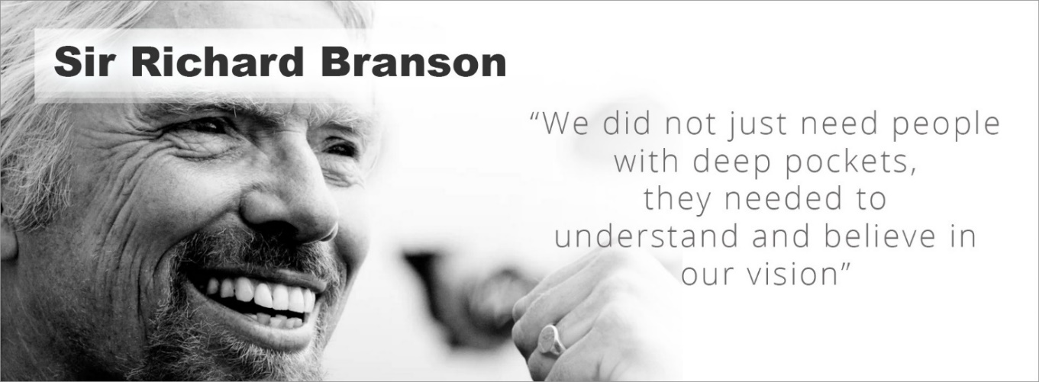
And to our esteemed potential investors, from the philanthropic visionaries at the Gates Foundation and Archewell to the business titans at Virgin Unite, Peter Thiel & John Doerr: Here lies an opportunity to invest in the future of online commerce, a revolution waiting to redefine industries.

Embrace the future. Be a part of this transformative journey."
End of content in the primary video
The end of the S-web.org homepage may conclude as follows linking us to sworld.org.

7. Expanding into Universal Market Solutions 💡
346 Words:
From the early days of www.S-World.biz's 600,000-word business plan and personal musings in 2011, our horizon has always been vast, encompassing more than just luxury vacation rentals. The ambition? Transforming this innovative system to cater to every product and service available, mirroring WordPress's adaptability but with unmatched functionalities.

Diving into Legal Services: As we plunge into this vast market, our pilot venture is into the realm of legal services. Why? It's strategic. We envision a legal firm eager to connect with our affluent network of villa owners and renters. It's not about cornering one segment but showcasing the S-Web 6 VC’s unparalleled adaptability across industries.

Generosity in Collaboration: Our belief? Generosity is key in business, especially when tapping into potent network effects. Giants like Sotheby's International Realty and Airbnb are on our radar, primarily due to their expansive networks. We're open to transformative collaborations, rolling out an attractive package replete with share options. Consider this: offering an S-Web 6 VC platform for every Sotheby's International Realty agent, or each Airbnb property owner. The speed and efficiency of this offering can revolutionize their businesses. Each listing or property could open up avenues for these agents and property owners to cross-sell a myriad of products and services, effectively augmenting their revenue streams.

The 'Swapping Menus Function' Advantage: This feature is the linchpin. It's what allows us to blur industry boundaries. With vacation rentals holding just 0.5% of the global GDP, our sights are set on the full spectrum. A staggering 2000x potential market growth awaits.

A Call to Action: The time is now. Dive deeper into the S-World ecosystem, a part of a revolutionary suite of technologies geared to redefine commerce. For a comprehensive look into our vision, visit www.s-world.org.

Understand the pivotal role S-Web is poised to play in this transformative journey. We aren't proposing a mere tech shift; we're spearheading a market revolution.

We call this market revolution HEAI — Human Economic AI
You can download an early draught of the 12,000-word S-WORLD HEAI at this link.
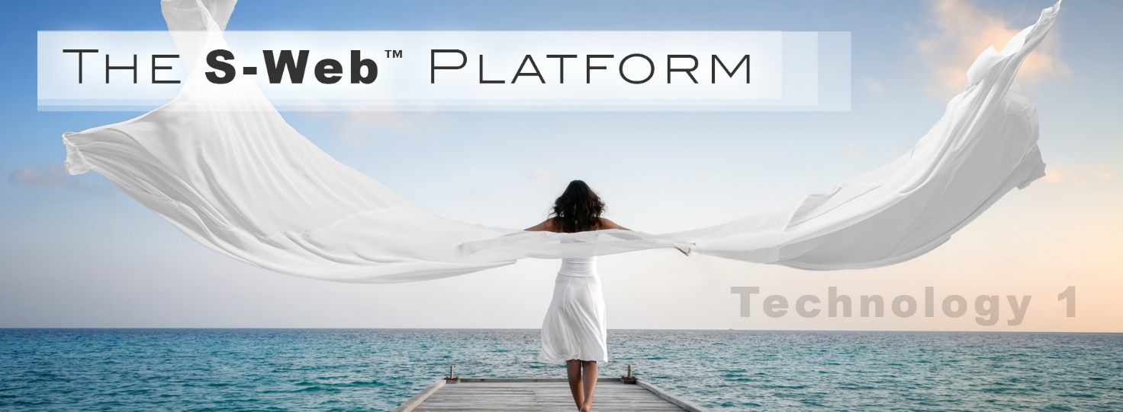

S-World ASI by Nick Ray Ball
1999 to 2023

Nick Ray Ball
Founder/CEO, and CTO
S-World ASI LTD UK
www.S-World.org
Company Number 14929119
128 City Road
London, EC1V 2NX
Contact
+44 7387 394 298
Websites:
www.CapeVillas.com (2000 /23)
www.ExperienceAfrica.com (2009/23)
www.AmericanButterfly.org (2012)
www.CapeLuxuryVillas.com (2015/23)
http://Network.VillaSecrets.com (2017/18)
www.AngelTheory.org (2018)
www.Supereconomics.ai (2019)
www.S-Web.org (2020/23)
www.S-World.org (2020/23)
www.NickRayBall.com (2023)
Media
Twitter.com/NickRayBall
Linkedin.com/in/Nick-Ray-Ball
Facebook.com/NickRayBall

